 CHEMICAL ENGINEERING TRANSACTIONS  VOL. xxx, 2025 | A publication of  
The Italian Association
of Chemical Engineering
Online at www.cetjournal.it
Guest Editors: Bruno Fabiano, Valerio Cozzani, Ales Bernatik
Copyright © 2025, AIDIC Servizi S.r.l.
ISBN 979-12-81206-xx-y; ISSN 2283-9216

Climate Resilience Assessment Methodology
Alexis Pey
Stahl Holdings bv, Pol. Ind. Llevant, c/ Llevant 7 - 08150 Parets del Vallès (Spain)
alexis.pey@stahl.com
Climate change is a phenomenon which can impact working and process conditions, as well as generate new scenarios for atmospheric hazards with potential impact on assets and operations.
According to most models, changes will occur over the years’ time scale, allowing industries to plan and implement safety measures, however, measures to be implemented may require significant investment and a rather long time for design and effective implementation.
For these reasons, it is important key define scenarios, plan actions well ahead, and approve investments on a technical basis.
With this purpose in mind, Stahl developed a new methodology to assess climate change resilience conditions and support the identification of climate change-related scenarios, the measure that may potentially be implemented and support the decision-making process in terms of investments.
The paper will present the methodology, analysis factors, risk assessment criteria and a worked example.
  - Introduction
Climate change is no longer a distant threat, it's a reality we face today, with its impacts becoming increasingly apparent and tangible year after year. As the world grapples with this global challenge, industries and organizations must adapt to ensure their resilience and continuity.
In response to this pressing issue, and having assessed current potential solutions, the final decision was to developed an own methodology to answer both internal and external needs.
The methodology adopted consists if the following main steps:
- Define potential climate change hazard scenarios
- Assess the consequences of these scenarios
- Determine the exposure and sensitivity to the identified consequences
- Formulate targeted actions and define plans to maintain operational effectiveness
The methodological basis has the aim of clearly establishing the relationship between the various risk components according to international reference guidelines (CEN-CENELEC, 2016)(IPCC, 2014)(IPCC, 2022) and norms (ISO, 2021).
The assessment primarily concentrates on manufacturing locations and strategic centres of excellence.
These key areas are evaluated for their vulnerability to hazards associated with extreme weather events, which are becoming more frequent and severe due to climate change.
Addressing climate change impacts often requires significant financial investments, extended planning periods, and lengthy implementation timelines. Because of this, by initiating this assessment process early and aiming to stay ahead of potential challenges, avoiding operational disruptions, and ensuring smooth transitions to new operational conditions.
This proactive approach allows the company to thoughtfully plan and implement necessary changes, rather than struggling to react to sudden environmental shifts.
Climate change is recognised no longer as an emerging risk, but as an actual hazards which needs to be considered in terms of operational resilience and business continuity.
By taking steps to understand and prepare for the impacts of climate change, companies are not only safeguarding its future but also contributing to the broader global effort to adapt to mitigate its effects.

  - Scenario Catalogue
    - Reference data
The definition of climate change scenarios starts by gathering data on potential climate conditions and their consequences on weather variables.
The scenario definition is equivalent to many risk assessment methodologies, a variable is chosen and then a condition is defined to make it drift out of the normal average parameters.
Uncertainty is related to the different prediction models available and potential evolution of climate temperature increase, in first place, and in second place to the effect that the temperature increase will have on other variables.
For the implementation of the methodology, public reference reports (IPCC,2023)(IPCC, 2022), and internal reports prepared by expert consultants have been considered.
    - Impact Variable
The impact variable refers to the specific climate factors being influence by the average temperature increase considered. These factors can include, but are not limited to:
- Temperature: heat waves (sustained higher temperature periods), and peak temperature values.
- Precipitation patterns: rain intensity, rain frequency, and rain period duration
- Wind speed: top windspeed
- Water levels: coastal linked to global water increase levels, and inland linked to rain conditions
- Extreme weather events: such as hurricanes and tornadoes
Each of these variables plays a crucial role in shaping the overall climate system and can have significant impacts on various sectors and ecosystems (WMO, 2021).
    - Scenario
The scenario parameter describes the deviation considered for the variable of interest. This deviation can be characterized in terms of magnitude, direction, or duration. Examples of scenarios include:
- Increase of heat waves duration and frequency
- Peak temperature increase or decrease
- Increase or decrease of rainfall amount in a single storm episode
- More frequent and intense extreme weather events
- Rain frequency increase or decrease
- Higher maximum wind speeds
These scenarios are typically based on climate model projections and consider different emissions pathways and socioeconomic developments (van Vuuren et al., 2011).
In the methodology proposed, at least two scenarios are defined in each impact variable, corresponding to a two different increase levels of temperature. This is in accordance with the interpretation of the CSRD requirements (European Union, 2022).
    - Scenario Detailed Description
For each scenario, a comprehensive and detailed description of the weather variable affected, and the potential consequences is prepared.
The description takes into account the local context and vulnerabilities, and aims to provide a clear understanding of the potential risks and opportunities associated with the scenario (NCA, 2018).
The detailed description shall be quantitative as much as possible, avoiding generic and qualitative parameters, allowing for assessing potential consequences in detail.
Examples of Scenario Detailed Descriptions are:
- Heat waves (maximum temperature above 35ºC) will be frequent for 3 months per year. Increase in thermal stress on job positions requiring physical activity. Heat stroke hazards are to be considered.
- Even if overall rainfall may decrease, the intensity of rain in the area will be a 20% higher in rainy episodes. Rainfall amount in peak episodes has the potential to cause flooding in the area disturbing supply chain for a period between 1 and 3 weeks.
- Peak windspeed increase during storms with a maximum registered of 120 km/h. Potential damage to structures and machinery, debris generation flying away and causing impacts on activities and assets around.
- Hail frequency increase to a critical episode per year, involving hail size up to 5 cm diameter. Hail may damage roofs, solar panels, and vehicles.
    - Confidence Factor
The confidence factor is a crucial parameter that quantifies the likelihood of the potential scenario occurring. It is defined by assessing the certainty of the available information and is expressed on a scale from 0.2 to 1:
- 1.0: Conditions already experienced OR absolute certainty
- 0.8: Modelled forecasts available with clear trends and the timeline for effects taking place
- 0.6: Modelled forecasts available with some discrepancy in terms of effect level and/or timeframe
- 0.4: Forecasts available with high uncertainty on the level of effect and/or timeframe
- 0.2: Forecast based on reasonable assumptions rather than models. No data on effects or timeframe.
This factor helps in prioritizing adaptation efforts and resource allocation based on the level of confidence in the projected scenarios.
    - Timeframe
The timeframe parameter indicates when, based on references and projections, the potential scenario is expected to occur. It is categorized into three main periods:
- Less than 5 years: Short-term impacts that require immediate attention and action
- Between 5 and 20 years: Medium-term effects that allow for strategic planning and implementation of adaptation measures
- Beyond 20 years: Long-term projections that may inform long-range planning and policy development
Some scenarios may be classified as "not relevant" if they are not expected to have significant impacts within the foreseeable future or are outside the scope of the assessment.
By systematically considering these parameters, decision-makers and planners can develop a comprehensive understanding of potential climate-related risks and opportunities, enabling them to formulate effective adaptation strategies and resilience-building measures.
The timeframe does not impact on the risk rating, it is assessed to support the action plan prioritisation.
  - Risk Rating
Finally, the risk rating is defined. To do so, the severity at local level and the confidence in the described scenario consequences are considered.
    - Local Impact
The local team conducts a comprehensive review and assessment of each scenario in the frame of the site of interest.
The local teams put the described scenario in the site's specific context, including its geographical location, existing infrastructure, and current operational procedures.
The local impact is assessed, when necessary, per plant, area and building of the site.
This process involves a detailed examination of the potential impacts that the new conditions may have on various aspects of the site. The assessment will consider factors such as:
- Infrastructure vulnerability
- Operational continuity
- Safety and security implications
- Environmental consequences
- Economic effects
- Regulatory compliance
    - Severity
Based on the assessment description, the severity is defined.
The severity refers to the extent or intensity of the negative impact or consequences of the potential scenario in the local context.
The severity is ranked as follows:
- No impact on the way to produce.
- Activities will require adaptation in line with best practices OR common improvement projects.
- Significant activity change OR impact on operational performance.
- Activity must stop due to environmental conditions or resource scarcity.
The severity criteria has been specifically defined for this type of assessment, the levels are defined based on the potential Key Risks described in public references (IPCC, 2023)(IPCC, 2022)

    - Climate impact
Finally, the climate impact is defined as a function between the Confidence Factor and the Severity.
As there are 5 levels of Confidence Factor and 4 level of Severity, there are 20 possible combinations.
In this sense, 5 impact levels have been defined:
- Acceptable Climate Impact: if the Climate Impact is in this area, No actions are required.
- Awareness on Climate Impact: if the Climate Impact is in this area, the evolution of forecasts and conditions shall be tracked, and potential solutions identified.
- Lower Priority Climate Impact: if the Climate Impact is in this area, Solutions to lower the potential impact should be selected & planned.
- Higher Priority Climate Impact: if the Climate Impact is in this area, Solutions to lower the potential impact must be implemented.
- Not acceptable Climate Impact: if the Climate Impact is in this area, the operations and processes must be stopped. The Climate Impact assessment will be reviewed by the top management, and a decision will be taken.
The climate impact value is determined in accordance with the following matrix:
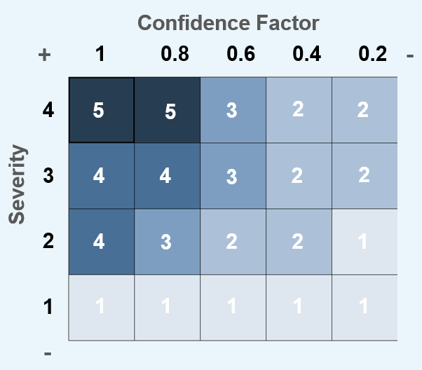
Figure 1: Climate Impact Matrix Criteria
  - Climate Resilience Condition
The last step of the assessment is to determine the climate resilience condition, meaning how prepared are the sites to stand the scenarios and impact levels determined.
    - Actions
To assess the climate resilience condition, the first step is to identify all the actions that need to be in place to ensure proper preparedness and enhance resilience.
These actions may include:
- Infrastructure improvements or reinforcements.
- Updates to emergency response plans.
- Staff training and capacity building.
- Implementation of new technologies or systems.
- Revision of operational procedures.
- Development of partnerships to improve the resilience in the area where the site is located.
Each action will be clearly outlined, including its objectives, required resources, timeline for implementation, and expected outcomes.
Once the actions are identified the status of each of them is assessed according to the following criteria:
- Action not started
- Potential solutions identified
- Solution selected & planned
- Solution implemented
- Activity/task stopped
The risk assessment template also allows the introduction of the potential options to implement the action, their cost estimation, and the budget year in which they are aimed to be executed.
    - Resilience condition
Finally, the resilience condition is calculated for each climate impact as the average difference between the Climate Impact Value and the average value of Action Status.

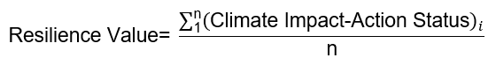 (1)

The resilience condition, in a sense, describes the level of readiness to face the expected impact, including its level of certainty.

The resilience condition is rated as follows:
Table 1: Resilience Assessment Criteria
Resilience Value | Resilience Condition | Related Risk Level
Value > 0.0 | Extra Resilient | Very Low
0.0 ≥ Value > -0.5 | Full Resilient | Acceptable
-0.5 ≥ Value > -1.5 | Almost Resilient | ALARP Low Priority
-1.5 ≥ Value > -3.0 | Not resilient | ALARP High Priority
-3.0 ≥ Value | Highly not resilient | Not Acceptable

High negative values on resilience condition show that action definition and planning are falling back on current resilience requirements. It shows that the scenario certainty and the severity of the impact are having a higher rating than the response given through the implementation of actions.
A resilience condition close to zero, shows that planning and action execution are in a state close to the current challenges caused by climate change conditions.
A positive resilience condition shows that preparedness to climate change is in an advanced state, hence climate change shall cause no significant impact on operations and businesses.
  - Example
An example has been prepared to visually illustrate the outlook of the climate change resilience assessment
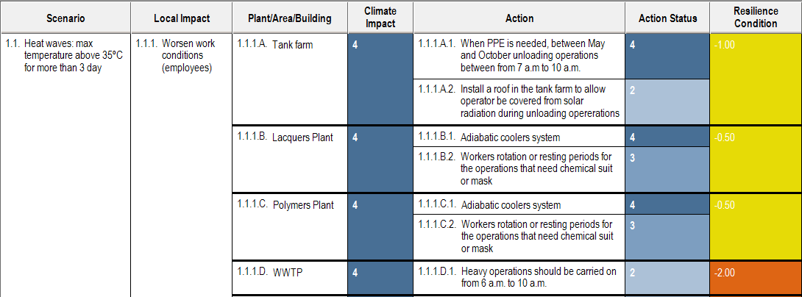
Figure 2: Climate resilience assessment example

  - Conclusions
The paper presents a comprehensive Climate Resilience Assessment Methodology developed by Stahl to address the impacts of climate change on its operations. This methodology enables Stahl to systematically evaluate climate change risks, plan appropriate adaptation measures, and make informed decisions regarding investments in climate resilience across their operational sites
Stahl's methodology for climate resilience combines proactive scenario planning with comprehensive data analysis. It integrates climate models, risk assessments, historical data, and stakeholder insights to define relevant climate scenarios and assess their potential consequences. Additionally, localized evaluations determine site-specific vulnerabilities and the severity of possible impacts.
A structured impact assessment uses a climate impact matrix to prioritize risks based on confidence levels and severity. This evaluation informs targeted action planning, identifying necessary measures and optimizing resource allocation. By aligning resilience assessments with Stahl’s Risk Acceptance Criteria Matrix, the methodology ensures seamless integration with existing risk management frameworks, enhancing long-term sustainability.
  - References
Butler C.D., Kuch D., 2018, The Medical Journal of Australia, 208, 296-301.
CEN-CENELEC, 2016. Guide 32, Guide for addressing climate change adaptation in standards.
European Environment Agency, 2017. Climate change, impacts and vulnerability in Europe 2016. EEA Report No 1/2017.
European Union, 2022. Directive (EU) 2022/2464 Of The European Parliament And Of The Council of 14 December 2022 amending Regulation (EU) No 537/2014, Directive 2004/109/EC, Directive 2006/43/EC and Directive 2013/34/EU, as regards corporate sustainability reporting
Haunschild R., Bornmann L., Marx W., 2016, Climate Change Research in View of Bibliometrics, PLOS ONE, 11, e0160393.
IPCC, 2014. Climate Change 2014: Impacts, Adaptation, and Vulnerability. Contribution of Working Group II to the Fifth Assessment Report of the Intergovernmental Panel on Climate Change.
IPCC, 2021, Climate Change 2021: The Physical Science Basis. Contribution of Working Group I to the Sixth Assessment Report of the Intergovernmental Panel on Climate Change, Cambridge University Press, Cambridge, UK.
IPCC, 2022: Climate Change 2022: Impacts, Adaptation and Vulnerability. Contribution of Working Group II to the Sixth Assessment Report of the Intergovernmental Panel on Climate Change. Cambridge University Press. Cambridge University Press, Cambridge, UK and New York, NY, USA.
ISO, 2021. EN ISO 14091, Adaptation to climate change, Guidelines on vulnerability, impacts and risk assessment.
NASA, 2024, Global Climate Change: Vital Signs of the Planet, National Aeronautics and Space Administration <climate.nasa.gov> accessed 27.09.2024.
National Climate Assessment, 2018. Fourth National Climate Assessment: Impacts, Risks, and Adaptation in the United States. U.S. Global Change Research Program.
Nature Climate Change, 2024, September 2024 Issue, Nature Portfolio <www.nature.com/nclimate/volumes/14/issues/9> accessed 27.09.2024.
UNFCCC, 2021, CGE Training materials on Vulnerability and adaptation assessment. Climate change scenarios, United Nations Framework Convention on Climate Change <unfccc.int/process-and-meetings/bodies/constituted-bodies/consultative-group-of-experts-cge/cge-training-materials/cge-training-materials-vulnerability-and-adaptation-assessment> accessed 27.09.2024.
van Vuuren, D. P., Edmonds, J., Kainuma, M., Riahi, K., Thomson, A., Hibbard, K., Hurtt, G. C., Kram, T., Krey, V., Lamarque, J. F., Masui, T., Meinshausen, M., Nakicenovic, N., Smith, S. J., & Rose, S. K, 2011. The representative concentration pathways: an overview. Climatic Change, 109(1-2), 5-31.
World Meteorological Organization, 2021. State of the Global Climate 2020. WMO-No. 1264.
WWF, 2024, Water Risk Filter, World Wildlife Fund <riskfilter.org/water/home> accessed 27.09.2024.

